Payment：

A.Testing Wallet:

QFPAY does not provide testing wallet to merchants, so please ask Chinese mainland colleague for help.

Alipay HK Wallet link:

<https://play.google.com/store/apps/details?id=hk.alipay.wallet&hl=zh-cn>

HK wallet only applicable offline quick pay right now.

If a customer uses a HK wallet to scan the Alipay QR code on a PC, it will shows like:

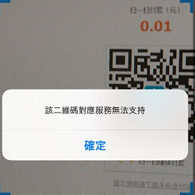

If a customer uses a HK wallet with WAP payment, it will shows like:

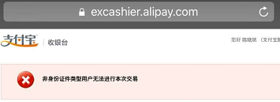

B.URL(Callback/Return)

They are set by QFPay staff, one appid can only have one pair of URL(Callback/Return).

Return URL:After success payment, it will redirect to that URL

Callback URL:After success payment, it will send notification to merchants’ back-end.(30s interval with 4 times)

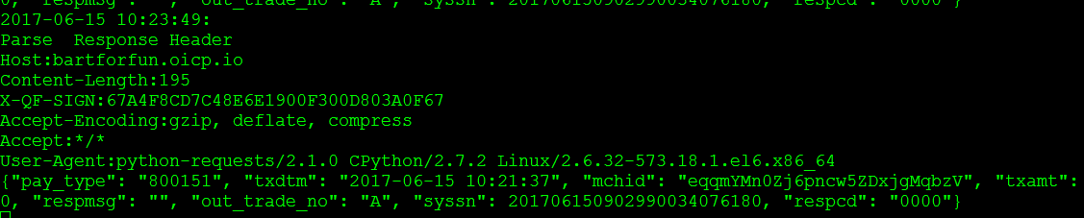

The above is the notification message.

C.Filter error:

When shows like below:

[respcd] => 1104

[respmsg] => filter error

It means this payment type is not available right now.

D.Refund：

A.What does 2999 means?

When invoke refund interface, sometimes, it will return like this:

{"orig_syssn":"201706090901990033885758","resperr":"交易失败，请联系客服(2999)","txdtm":"2017-06-09 19:16:36","txamt":"1","respmsg":"","out_trade_no":"qfpay_alipay999920170609191636","syssn":"201706090901990033885799","origssn":"201706090901990033885758","respcd":"2999","sysdtm":"2017-06-09 19:16:21"}

2999 means in pending state. After transaction finishes, the merchant backend should use query interface to check the transaction is OK.

E.product_name：

From Alipay APP：

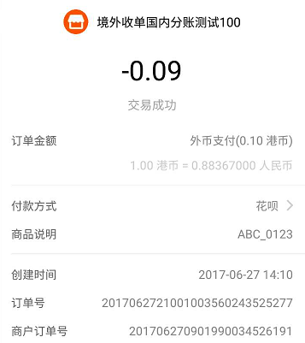

订单号：Alipay reference number

商户订单号：QFPay reference number

商品说明:product_name(Please use shop name+out_trade_no format for reference)

Wechat:

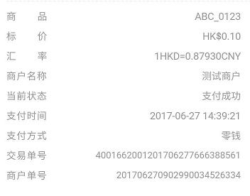

交易单号：Wechat reference number

商户单号：QFPay reference number

商品：product_name(Please use shop name+out_trade_no format for reference)